Monthly Checklist for Dealership Controllers
“Behind every good business owner there is a great accountant.”

Week 2:

- Create A/P Checks
- Payroll
- Review outstanding Floorplan payables
- Reconcile manufacturer statements
- Pay due balances
- Update Bank Reconciliation each week (or day) and clear checks, deposits, JE’s etc. that have cleared the bank
- Close previous month once all reconciliation has been complete
- Post any outstanding GL transactions
- Verify Subledger Balance report is balanced
- Verify cash on-hand and bank account is balanced

Week 4:

- Create A/P Checks
- Payroll
- Review contracts in transit
- Update Bank Reconciliation each week (or day) and clear checks, deposits, JE’s etc. that have cleared the bank
- Meet with Service Manager to review WIP
- Meet with Parts Manager to review Open Purchase Orders
- Review unmerged credits on AR accounts
- Post Interest and run AR statements
- Review unit inventory balance sheets and compare subtotals
- Reconcile parts pad with GL and do a gap analysis where applicable

Week 1:

- Create A/P Checks
- Payroll
- Update Bank Reconciliation each week (or day) and clear checks, deposits, JE’s etc. that have cleared the bank
- Print sales analysis and profit reports to review for the previous month
- Pull commission report for sales in previous month
- Run Trial Balance for previous month to find any discrepancies

Week 3:

- Create A/P Checks
- Payroll
- Review aged A/R ahead of running statements
- Update Bank Reconciliation each week (or day) and clear checks, deposits, JE’s etc. that have cleared the bank
- Run Sales Tax report to pay state taxes

Daily:

- Post daily Point of Sale batches
- Input all money received – cash, checks, credit cards, wire transfers, etc.
- Update Bank Deposit
- Review End-of-Day reports
- On Parts End-of-Day review for parts selling below cost and low margins
- On Accounting End-of-Day verify Subledger Balance report has no variances
- Input all Accounts Payable invoices received in mail, email, or automatic debits from bank
- Input all Unit Inventory that has arrived
- Input all Completed Unit Sales (Post Deals)
- Enter Equipment Rental invoices as needed
- Post GL Transactions

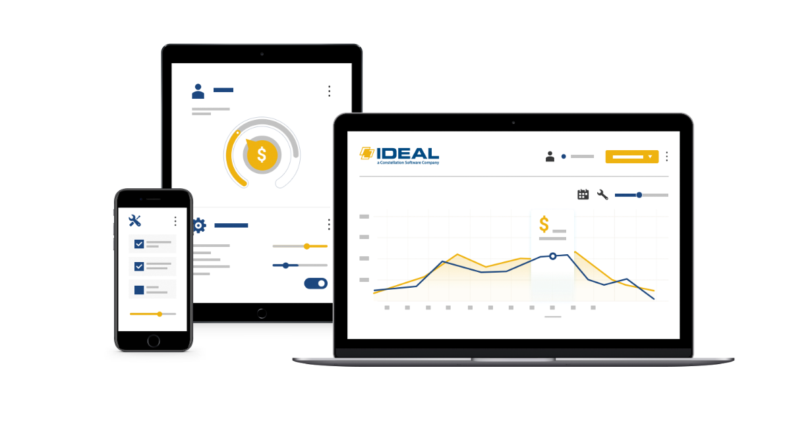
Ready to boost productivity and efficiency at your dealership?
Ideal Computer Systems offers the most comprehensive set of tools for managing dealerships of any size. By working with dealers for over 30 years, we developed an all-in-one dealership management system that is intuitive and easy to use. Ideal provides you with everything you need to run your dealership: inventory control, shop management, sales, CRM, accounting, rental, reports, and more.

Learn more about what Ideal can do for your dealership.
Call us at 800-737-1620

